**Amine LOUATI**

**How to enhance Fiori launchpad**

1. Purpose of the document 3

2. SAPUI5 application: 4

2.1. Get and set Data: 4

2.2. Add Action button 5

3. In Fiori Designer 8

3.1. Create a new target mapping 8

4 Conclusion: 9

# Purpose of the document

The purpose of the document is to describe how to enhance Fiori Launchpad 2.0.

Using library [sap.ushell.renderers.fiori2.Renderer](https://sapui5.hana.ondemand.com/#/api/sap.ushell.renderers.fiori2.Renderer), we can add, remove hide different components of the Launchpad.

In our example, we will add an action button that open a dialog box, used to fill default values for organization fields (like company code, Po Org…).

The user input will be GET and SET using [sap.ushell.services.PersonalizationContainer](https://sapui5.hana.ondemand.com/#/api/sap.ushell.services.PersonalizationContainer).

# SAPUI5 application:

Create a SAPUI5 application that contains only component.js file.

The component extends the class [sap.ui.core.Component](https://sapui5.hana.ondemand.com/#/api/sap.ui.core.Component).

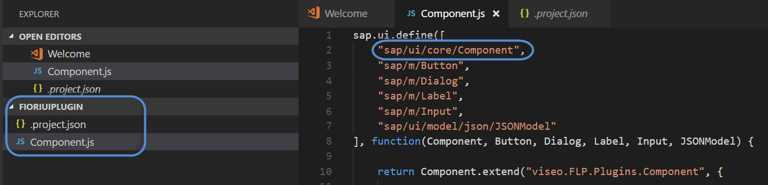

In the init method,

We will first create a JSON model that will contain datas.

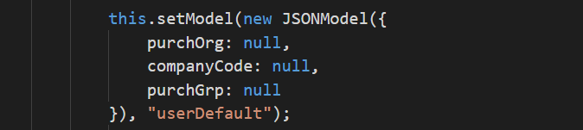

# Get and set Data:

Data are fetched from the backend using the personalization service.

In the init method, we call internal method _getPersonalizationData

In this method:

1. First we get the personalization service.
2. Read data from backend
3. Store the result in the local Json Model.

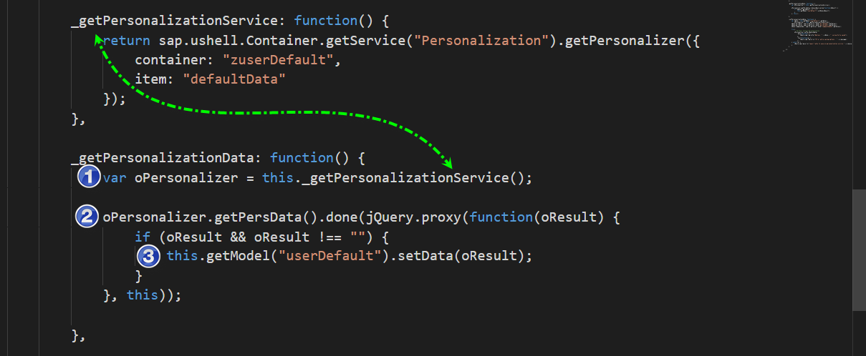

Data are sent to the backend using internal method _setPersonnalizationData

1. first we get the personalization service.
2. Read data from input fields
3. Send the data to backend.

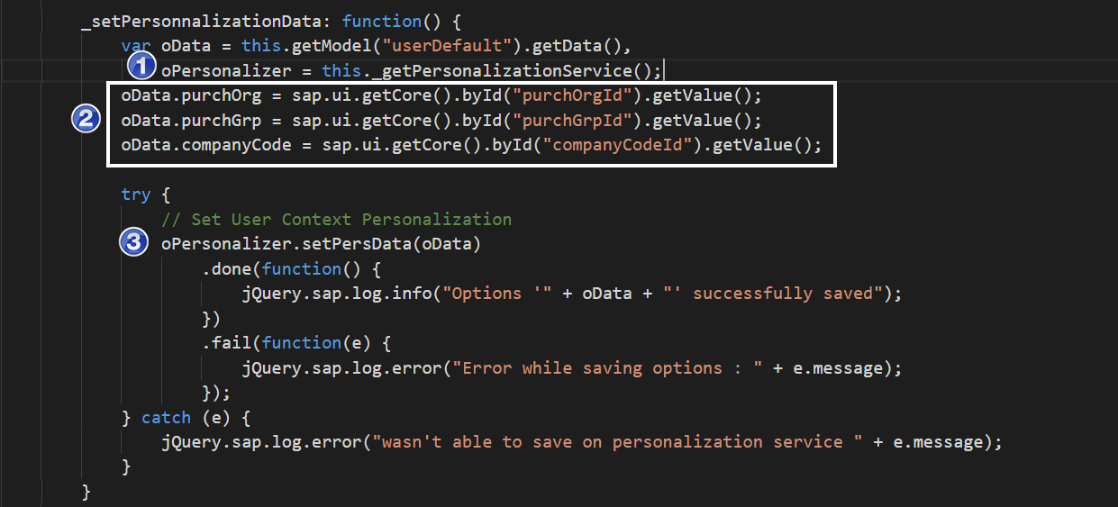

**NB**: The personalization service uses oData Service INTEROP to communicate with the backend.

# Add Action button

Also in the init method, create an action button using method addActionMethod of the renderer.

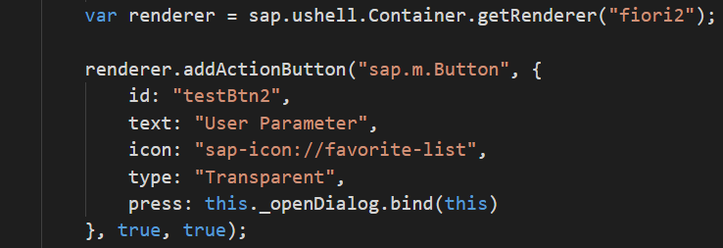

The button contains a handler of the event press.

In the handler, we will create a Dialog box for user interaction.

This is done in method _openDialog:

Create simple form components with input fields, input values come from the Json model.

Create Dialog containing the Form and OK/Cancel buttons.

The OK button will call method _setPersonnalizationData before closing the Dialog box

The Cancel Button will just Close the Dialog.

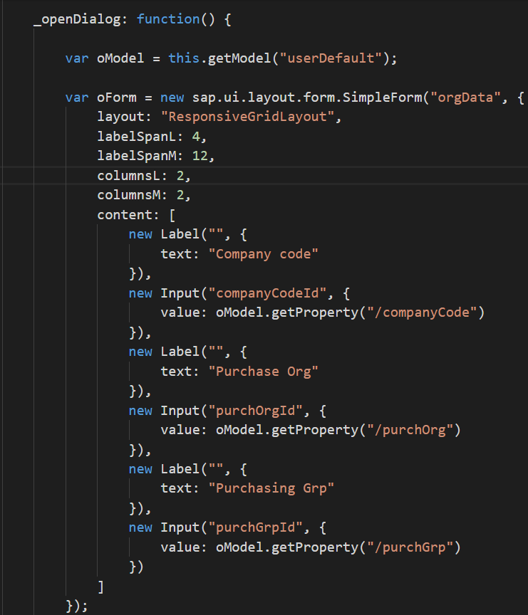

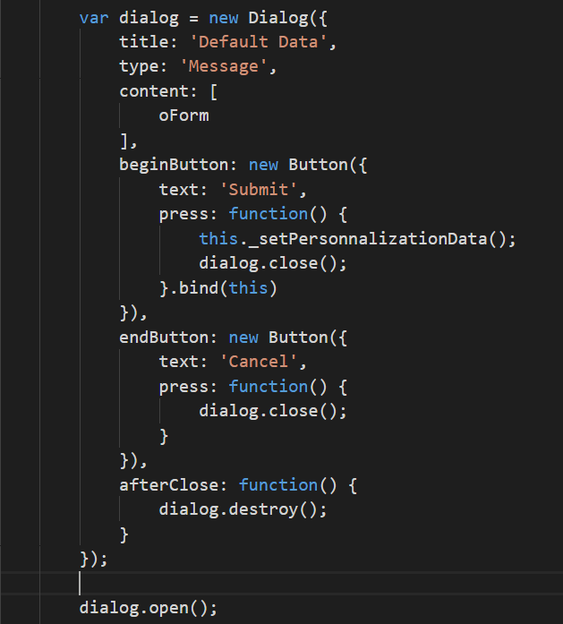

NB: I offer a beer to the one who will find a way to bind input fields to the Json model.

# In Fiori Designer

# Create a new target mapping

In a catalog, create a new target mapping to the application with the following information’s:

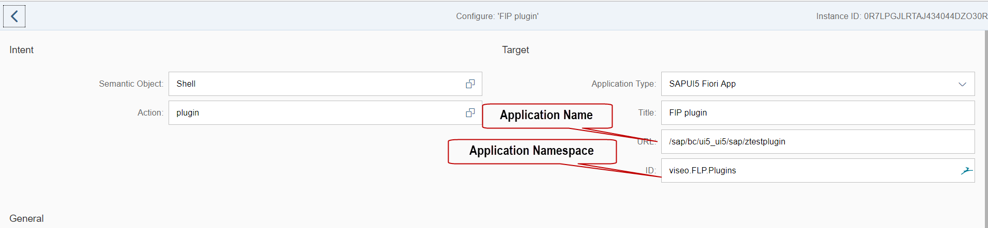

As a result, in Fiori Launchpad:

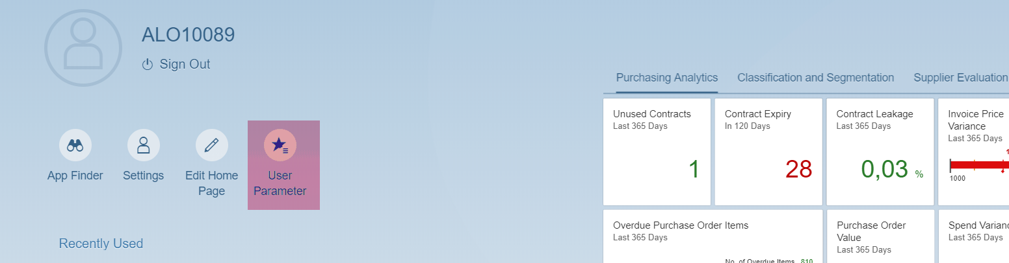

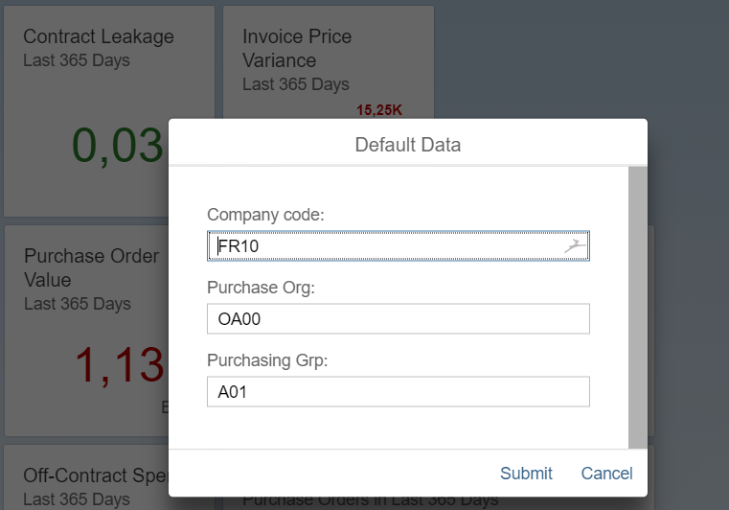

# Conclusion:

Using The renderer library, we can know enhance Fiori Launchpad.

Using the personalisation, we can know store information in the back end without creating a specific oData service and we can use it in any Fiori Application.

Note that the personalisation service is a part of FIORI and cannot be used in standalone SAPUI5 application.

